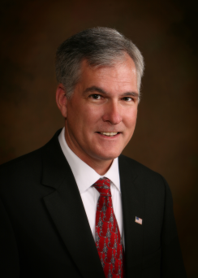

OFFICE OF THE COLE COUNTY PROSECUTING ATTORNEY
MARK A. RICHARDSON, PROSECUTOR
NEWS RELEASE
Cole County Courthouse Annex | 311 East High Street, Third Floor | Jefferson City, Missouri 65101
Tel. (573) 634.9180 | Fax (573) 634.7797 | Web www.colecopa.com

FOR IMMEDIATE RELEASE
September 20, 2018

CONTACT
Randy Dampf, (573) 634-9180

The Missouri Attorney General’s Office requested criminal misdemeanor charges against four former state employees involving Help, Inc.
This office conducted a detailed investigation into the allegations raised in the Missouri State Auditor’s report regarding four former state employees with Help, Inc. This office interviewed witnesses and the four individuals named in the Auditor’s report. Also, several documents were reviewed including documentation provided by the Attorney General’s office and the report made by the State Auditor’s office. After that investigation and after due consideration, I have found no probable cause of any criminal violation under Missouri law. Therefore, I will not file any criminal charges arising out of the Help, Inc. investigation against Jan Skouby, Scott Marion, Greg Kindle and Brett Johnson.
My response to the Attorney General’s office declining charges is attached.

-30-

